Full Stack Development with MERN
Project Documentation format
1. Introduction
- Project Title: Script-Controlled ACL – Restrict Record Access Based on Field Value
- Team Members: [Member Name 1] – [Role], [Member Name 2] – [Role], [Member Name 3] – [Role]
2. Project Overview
- Purpose: This lab demonstrates how to implement a script-controlled Access Control List (ACL) to restrict users from viewing records unless they meet specific conditions. In this scenario, only users belonging to the EEE branch are allowed to view records where the Branch field is set to EEE, while administrators retain full access.
- Features: Script-controlled READ, WRITE, CREATE and DELETE ACLs enforce record-level security. User roles and record field values are evaluated together to make access decisions. ACLs protect sensitive data from unauthorized viewing, modification, creation and deletion across forms, lists and Service Portal interfaces.
3. Architecture
- Frontend: ServiceNow instance interface – Application Navigator, the Institution Details list (u_institution_details.list) and record forms, where users view records according to their roles.
- Backend: Access Control (ACL) rules under System Security, created with the security_admin role elevated. The READ ACL uses an advanced script that checks roles with gs.hasRole(); CREATE, WRITE and DELETE ACLs use required roles (bb2, bb3, bb4).
- Database: Custom table Institution Details (u_institution_details), Extends for: false, with the following fields:
  - Student Roll Number – Auto Number
  - Student Name – Reference (User)
  - Faculty Name – Reference (User)
  - Branch – Choice (ECE, EEE, CSE)
  - Email – String
  - Phone Number – String
  - Description – Multi String
4. Setup Instructions
- Prerequisites: ServiceNow instance with admin access; security_admin role elevation (required to create ACLs).
- Installation: Step-by-step guide (Phases 1–3):
  - Phase 1 – Users Creation: Log in to the ServiceNow instance with admin access. Create a test user.
    - Navigate to User Administration → Users and click New.
    - User ID: EEE User; First name: EEE; Last name: User; Email: eeeuser@gmail.com.
    - Save the record.
  - Phase 2 – Roles Creation: Navigate to User Administration → Roles.
    - Click New; Name: bb1; Description: brief role purpose; click Submit.
    - Create the other roles bb2, bb3 and bb4 by following the same procedure.
    - Assign all the roles to the EEE User.
  - Phase 3 – Creation of Table: In the Application Navigator, search for System Definition → Tables.
    - Click New; Label: Institution Details; Name: u_institution_details; Extends for: false; click Submit.
    - Add the fields listed under Database (Section 3) and save the table.
    - Create multiple records in the Student Records table with different Branch values (ECE, EEE, CSE).
5. Folder Structure
- Client: User Administration → Users (EEE User); User Administration → Roles (bb1, bb2, bb3, bb4); System Definition → Tables (u_institution_details); u_institution_details.list (Student Records list).
- Server: System Security → Access Control (ACL) – Read, Create, Write and Delete ACLs on u_institution_details.
6. Running the Application
- After the ACLs are created, verify access as follows:
  - Impersonate the EEE user and open the Student Records list.
  - Copy the table name u_institution_details.list/LIST and paste it in the All menu.
  - Impersonate Admin and open the Student Records list.
7. API Documentation
- ACLs on the table u_institution_details (Type: record, Active: true):
  - Read: Requires role bb1; data condition Branch is EEE; Advanced: true with script (see Section 8).
  - Create: Requires role bb2; no data condition.
  - Write: Requires role bb3; no data condition.
  - Delete: Requires role bb4; no data condition.
8. Authentication
- Authorization is handled through roles (bb1–bb4) assigned to the EEE User and record-level ACLs; the admin user always has full access. ACLs are created after elevating the security_admin role.
  - Phase 4 – ACL Configuration (Read ACL): Search for System Security → Access Control (ACL), elevate “Security_admin” and click New.
    - Type: record; Operation: read; Name: u_institution_details; Active: true; Advanced: true.
    - In the Requires role related list, add bb1 (custom role).
    - Add Data condition: Branch is EEE.
    - In the Script field, add the following script, then click Submit:
(function () {
// Allow admin users full access
if (gs.hasRole('admin')) {
return true;
}

// Allow only EEE branch users to see EEE records
if (gs.hasRole('bb1')) {
return true;
}

// Deny access for all others
return false;
})();
  - Phase 5 – Creation of ACL-Create: Click New.
    - Type: record; Operation: create; Name: u_institution_details; Active: true.
    - In the Requires role related list, add bb2 (custom role). No data condition. Save the ACL record.
  - Phase 6 – Creation of ACL-Write: Click New.
    - Type: record; Operation: Write; Name: u_institution_details; Active: true.
    - In the Requires role related list, add bb3 (custom role). No data condition. Save the ACL record.
  - Phase 7 – Creation of ACL-Delete: Click New.
    - Type: record; Operation: Delete; Name: u_institution_details; Active: true.
    - In the Requires role related list, add bb4 (custom role). No data condition. Save the ACL record.
9. User Interface
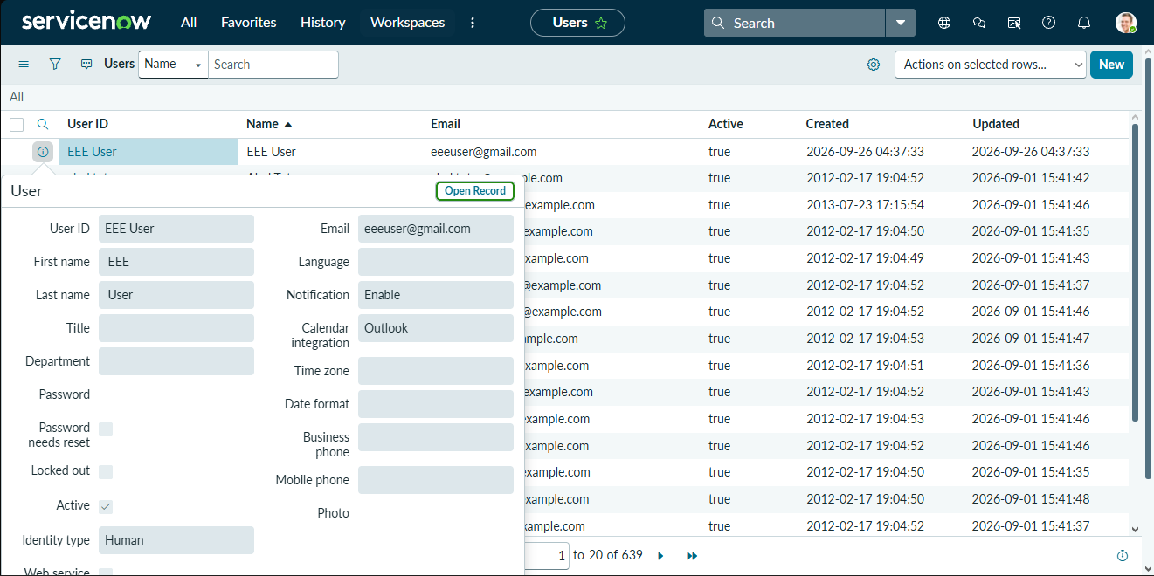
Screenshot – User Creation
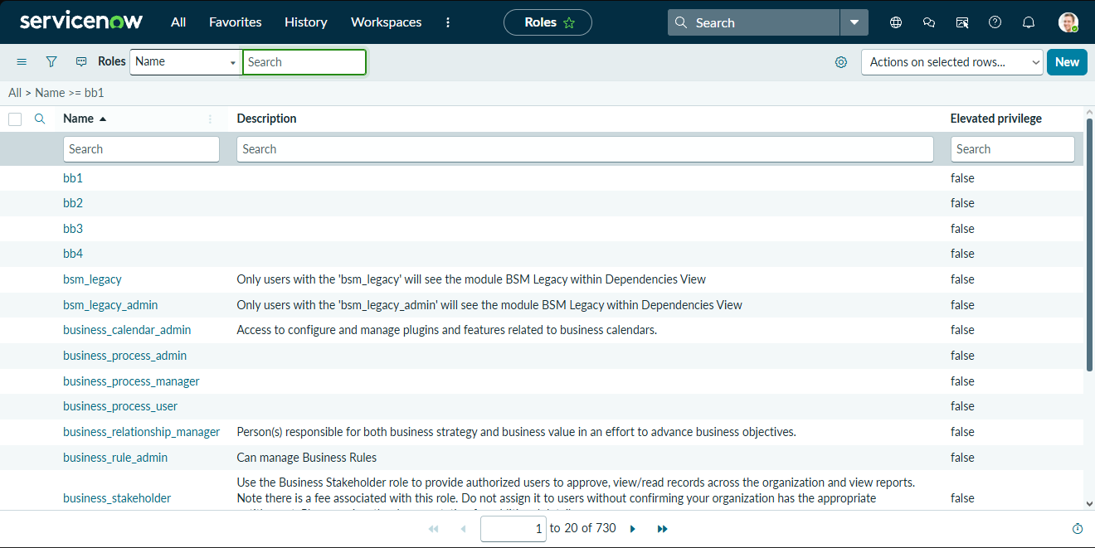
Screenshot – Role Creation
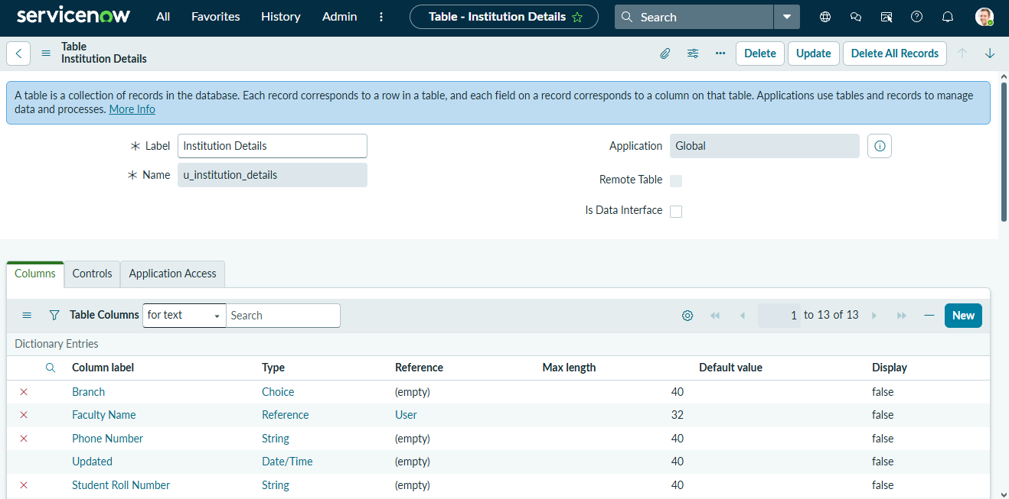
Screenshot – Table Creation
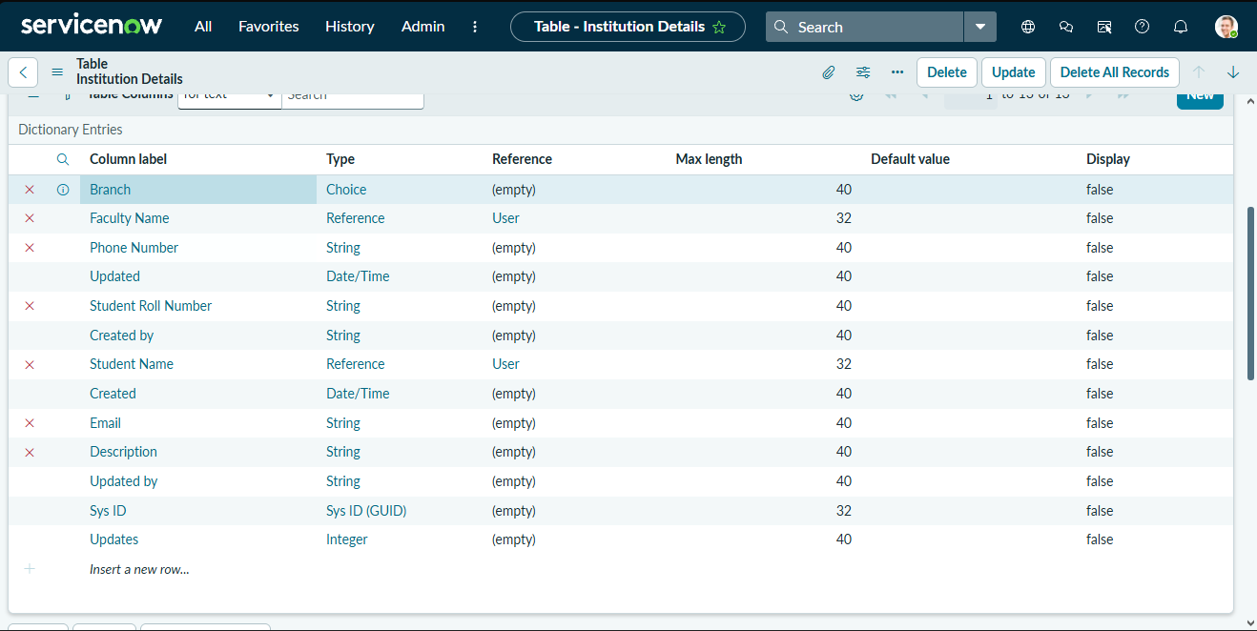
Screenshot – Table Fields
10. Testing
- Testing is done by impersonating users and opening the Student Records list. Verify:
  - User with bb1 role can view only EEE branch records.
  - User without the role cannot view any records.
  - Admin user can view all records regardless of branch.
11. Screenshots or Demo
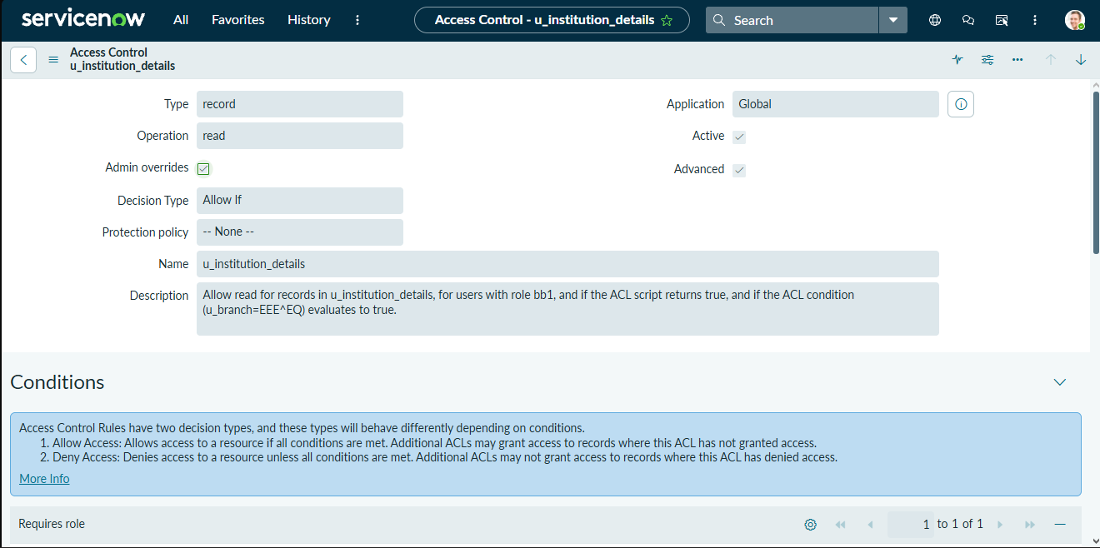
Screenshot – ACL Configuration
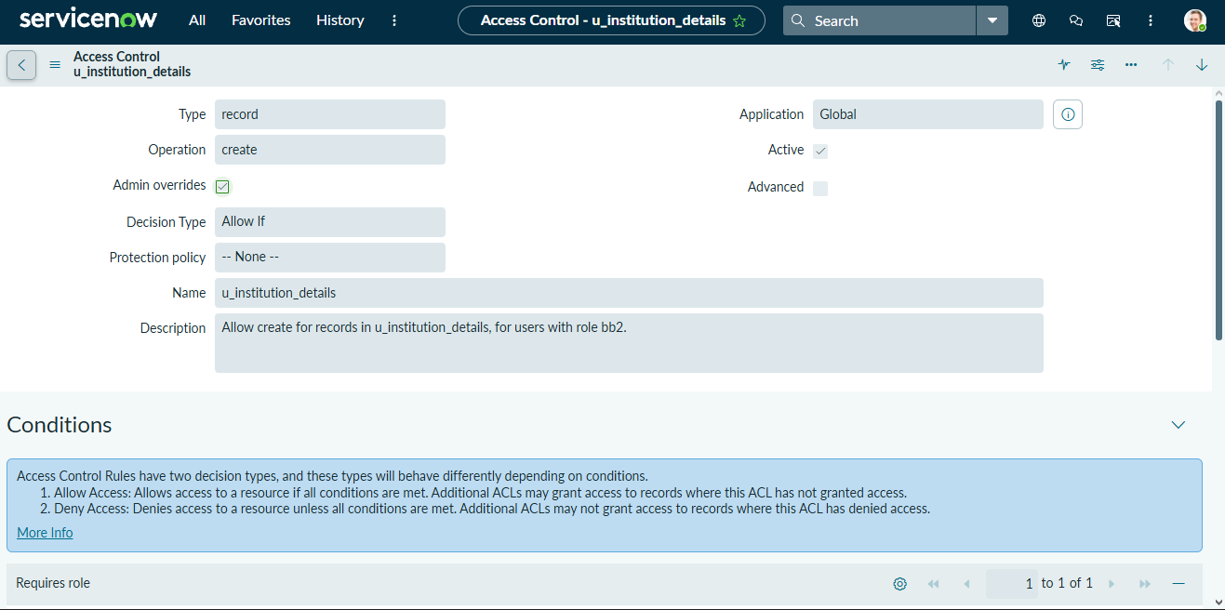
Screenshot – ACL Create Configuration
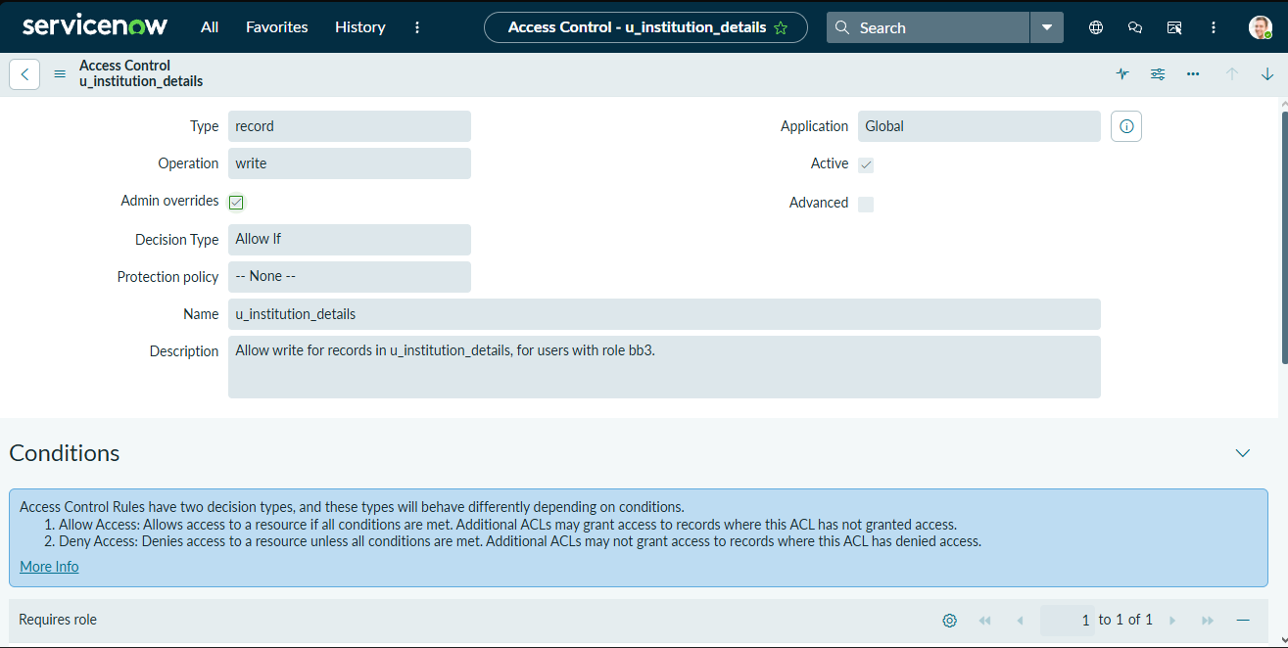
Screenshot – ACL Write Configuration
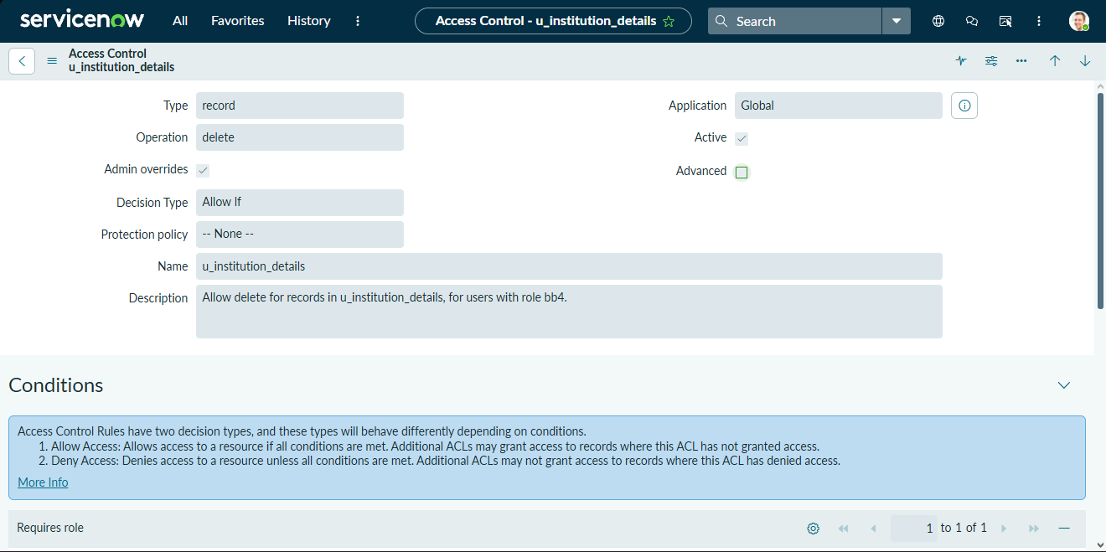
Screenshot – ACL Delete Configuration
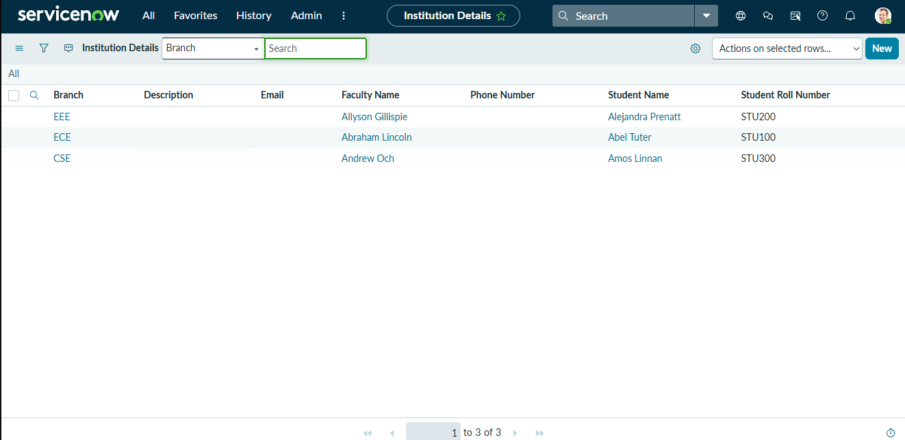
Screenshot – Final Record Access Result
12. Known Issues
- No known issues are mentioned in the Phase-wise document.
13. Future Enhancements
- Apply the same script-controlled ACL approach to the other branches (ECE, CSE) and to Service Portal interfaces.

